# **C3-S8 –PRACTICE**

## EX1

-Enter 4 strings in the console (s1; s2; s3; s4)

-Print the length of this strings separated by "-"

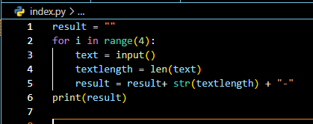

>Ronan

>Channak

>Seiha

>Hugo

>5-7-5-4

## EX2

-Enter a string **word** in the console

- **n** is the length of **word**

-Print **n** times the character "Y” (in one line, no line break)

**!! You can use only 1 print instruction!!**

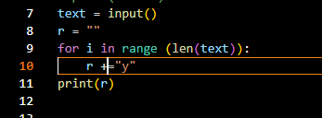Ex 1:

>hello

>YYYYY

Ex 2:

>KhmerNewYear

>YYYYYYYYYY

## EX3

Enter a string **word** in the console

-Print "It's small !" if the number of letters is less or equal than 3

-Print "It's medium !" if the number of letters is between 4 and 6 or between 8 and 10

-Print "It's exactly the average !" if the number of letters is 7

-Print "It’s big !" if the number of letters is upper or equal than 11

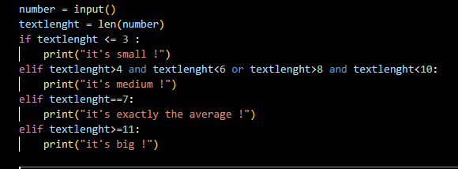Ex 1:

>hello

>It's medium !

Ex 2:

>KhmerNewYear

>It's big !

## EX4

-Enter a number **number** in the console

-Enter a string **mode** in the console: **mode** can "inside" or "outside"

- Create a boolean with the following value :

- if mode is "inside" : it's true only if <number> is in the range [1, 10]

- if mode is "outside" : it's true only if <number> is less than 1 or greater than 10

- Print the boolean value

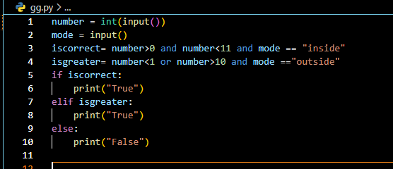Ex 1 :

>5

>inside

>True

Ex 2:

>5

>outside

>False

Ex 3:

>0

>outside

>True

## EX5

-Enter a string **word** in the console

- **n** is the length of **word**

-Print **n** times the string, but remove one more letter from the end each time

**Note: To remove the last character of the string variable "word" --> word = word[:-1]**

Ex 1:

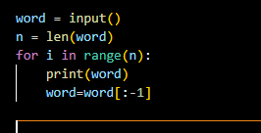>hello

>hello

>hell

>hel

>he

>h

Ex 2:

>KhmerNewYear

>KhmerNewYear

>KhmerNewYea

>KhmerNewYe

>KhmerNewY

>KhmerNew

>KhmerNe

>KhmerN

>Khmer

>Khme

>Khm

>Kh

>K

## EX6

-Enter a number **n** in the console

-Print a reversed triangle of X (see examples)

**!! You can use only 1 print instruction!!**

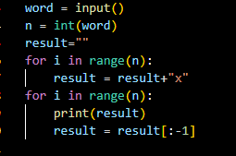

Ex:

>4

>XXXX

>XXX

>XX

>X

>2

>XX

>X

Note: here we **don’t allow** you to use this Python instruction:

myText = “X” * 10

Why? Because it’s too easy like this! **You need to learn to use 2 REPEAT-N-TIME** **S**